FINAL PROJECT REPORT

Project Title
EduGenie – Google Gemini Powered Learning Assistant
Internship: Google Cloud Generative AI Virtual Internship
Technology Used:
- Python 3.10+
- FastAPI
- Google Gemini 1.5 Pro
- LaMini-Flan-T5-783M
- HTML
- CSS
- Jinja2
- SQLite / PostgreSQL
- Uvicorn

1. INTRODUCTION
1.1 Project Overview
EduGenie is a lightweight AI-powered educational assistant developed to simplify and enhance the learning experience using Generative Artificial Intelligence. The application assists students, educators, and self-learners by providing intelligent educational services such as Question Answering, Concept Explanation, Quiz Generation, Text Summarization, and Personalized Learning Recommendations.
The project combines Google Gemini 1.5 Pro for advanced AI capabilities with the lightweight LaMini-Flan-T5 model for local concept explanations. Built using FastAPI for the backend and HTML, CSS, and Jinja2 for the frontend, EduGenie offers a responsive and interactive web interface that enables users to receive real-time educational assistance.

1.2 Purpose
The primary purpose of EduGenie is to provide an integrated AI-powered educational platform that improves learning efficiency and reduces the time required to search for educational resources. The system enables users to:
- Ask educational questions
- Understand difficult concepts
- Generate quizzes
- Summarize lengthy educational content
- Receive personalized learning paths
The project aims to make learning more accessible, interactive, and personalized.

2. IDEATION PHASE
2.1 Problem Statement
Students often struggle to understand complex concepts, summarize long study materials, generate practice quizzes, and obtain structured learning guidance. Existing educational platforms generally provide only one or two of these services, forcing users to switch between multiple applications.
EduGenie addresses these issues by integrating multiple AI-powered educational functionalities into a single platform.

2.2 Empathy Map Canvas
Think & Feel
- Need quick educational assistance
- Want simplified explanations
- Save study time
- Prepare better for exams
Hear
- Teacher recommendations
- Friends discussing AI learning
- Educational YouTube channels
See
- Lengthy textbooks
- Multiple learning websites
- Growing use of AI in education
Say & Do
- Search educational topics online
- Watch tutorials
- Practice quizzes
- Ask teachers for help
Pain Points
- Difficult concepts
- Information overload
- No personalized guidance
- Time-consuming study process
Gains
- Quick answers
- Better understanding
- Personalized learning roadmap
- Improved confidence

2.3 Brainstorming
The team explored different approaches to improve educational assistance using AI. After evaluating multiple ideas, the following core features were finalized:
- AI Question Answering
- Concept Explanation
- Quiz Generation
- Text Summarization
- Personalized Learning Path Recommendation

3. REQUIREMENT ANALYSIS
3.1 Customer Journey Map
User Journey
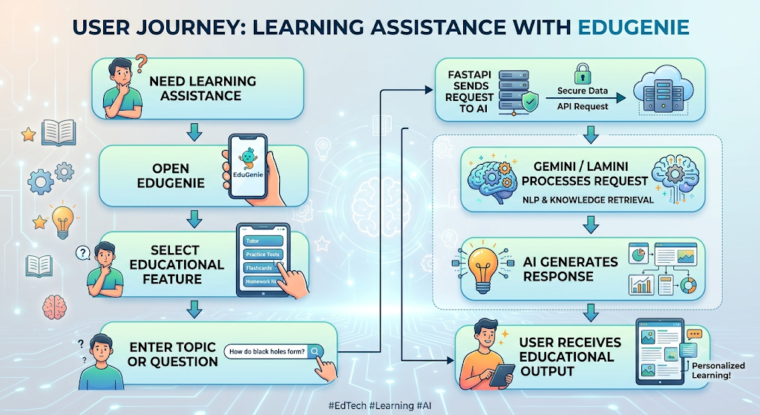

3.2 Solution Requirements
Functional Requirements
- User Registration
- Login
- Question Answering
- Concept Explanation
- Quiz Generation
- Text Summarization
- Learning Recommendations
- Database Management
- REST API Integration
- Responsive Web Interface
Non-functional Requirements
- Security
- Reliability
- Scalability
- Performance
- Maintainability
- Portability
- Compatibility

3.3 Data Flow Diagram
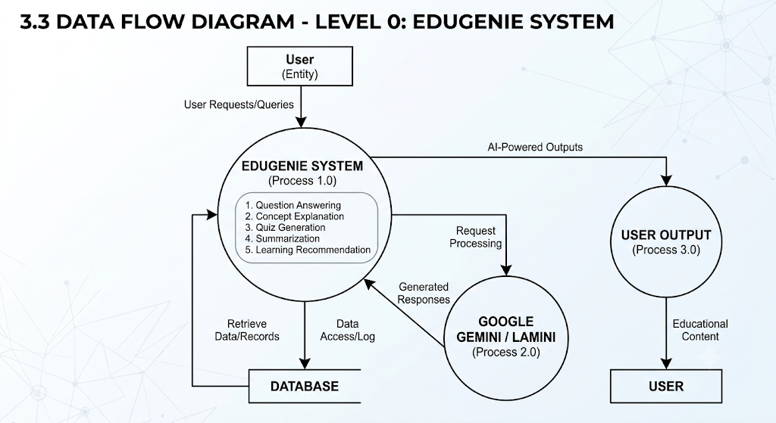

3.4 Technology Stack
Layer | Technology
Frontend | HTML, CSS, Jinja2
Backend | FastAPI
AI Model | Google Gemini 1.5 Pro
Local Model | LaMini-Flan-T5
Database | SQLite / PostgreSQL
Server | Uvicorn
Language | Python
IDE | VS Code

4. PROJECT DESIGN
4.1 Problem Solution Fit
Customer
Students
Educators
Self Learners
Problems
- Difficult concepts
- Long notes
- No learning guidance
- Lack of quizzes
Solution
EduGenie integrates all educational AI services into one platform.

4.2 Proposed Solution
EduGenie provides:
- AI Question Answering
- AI Explanation
- Quiz Generation
- Text Summarization
- Personalized Learning Recommendations
using Google Gemini and LaMini-Flan-T5.

4.3 Solution Architecture
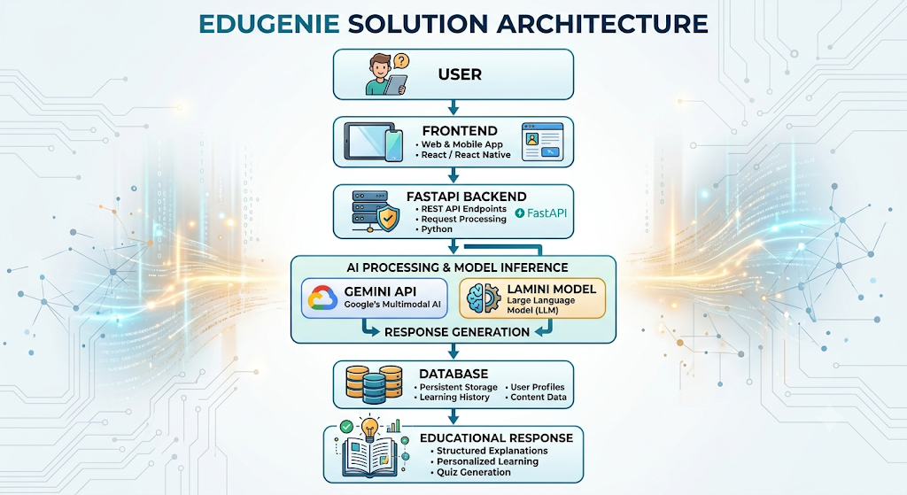
5. PROJECT PLANNING & SCHEDULING
5.1 Project Planning
Sprint 1
- Model Selection
- FastAPI Setup
- Project Architecture
Sprint 2
- AI Module Development
- Frontend Development
Sprint 3
- Database Integration
- API Integration
- Testing
Sprint 4
- Deployment
- Functional Testing
- Performance Testing

6. FUNCTIONAL AND PERFORMANCE TESTING
6.1 Functional Testing
Performed testing for:
- Question Answering
- Explanation Module
- Quiz Generation
- Summarization
- Learning Recommendation
- API Integration
- Database Operations
Result:
All Test Cases Passed Successfully

Performance Testing
Tested:
- Response Time
- API Speed
- Multiple Requests
- Long Text Processing
- Local Deployment
Average response time:
3–5 Seconds

7. RESULTS
7.1 Output Screenshots
Include screenshots of:
- Home Page
- 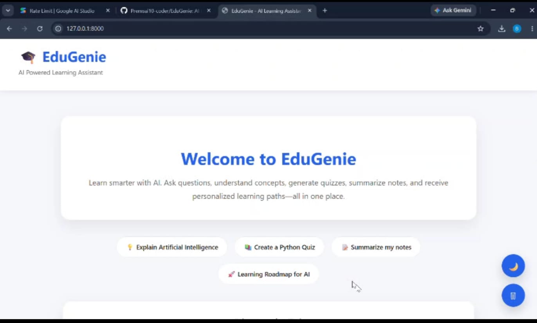
- Question Answering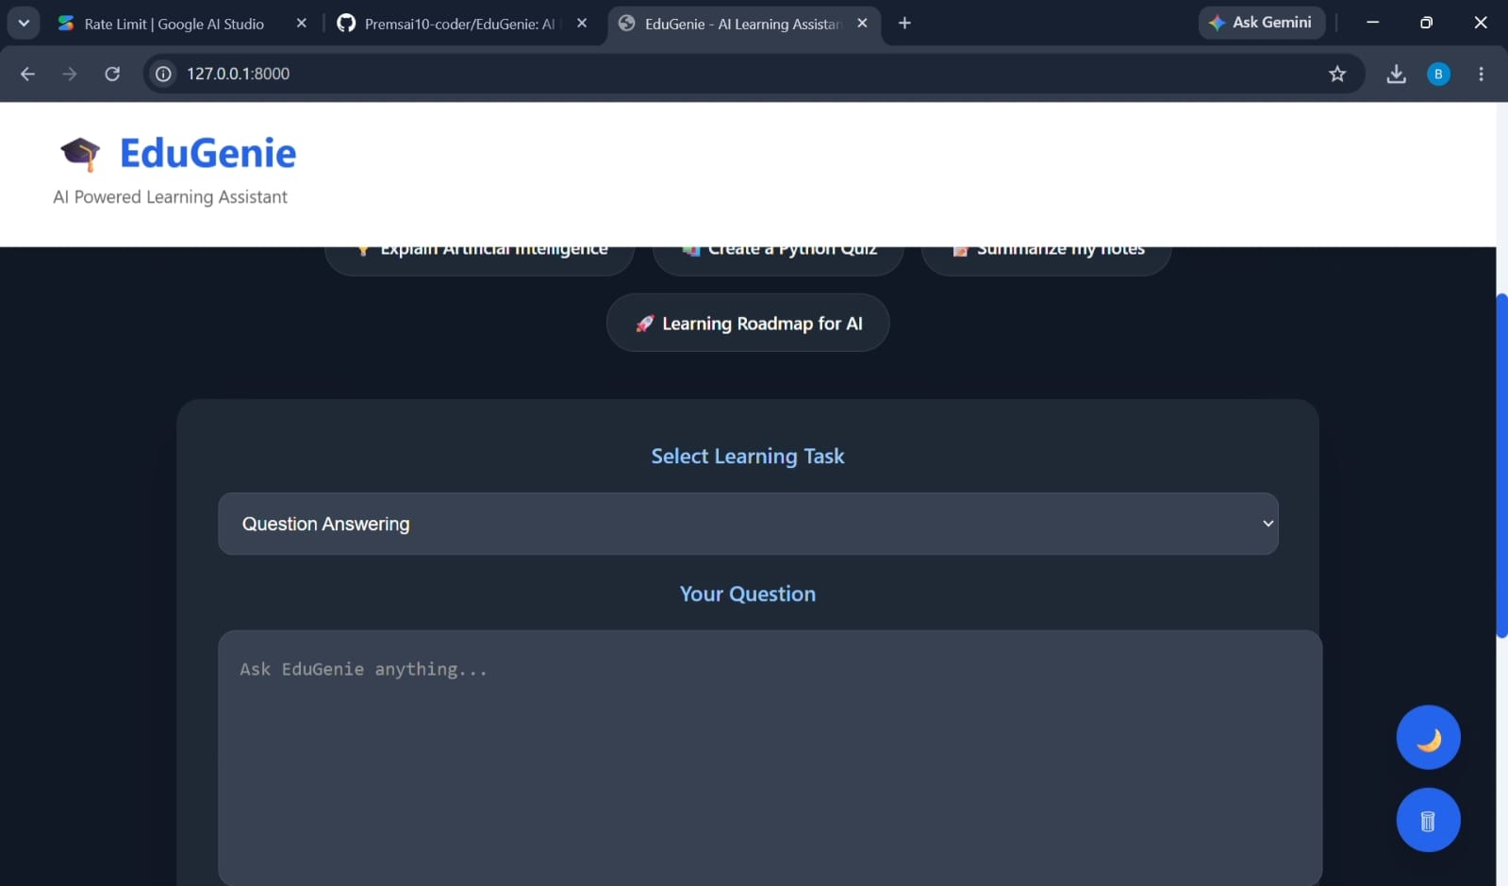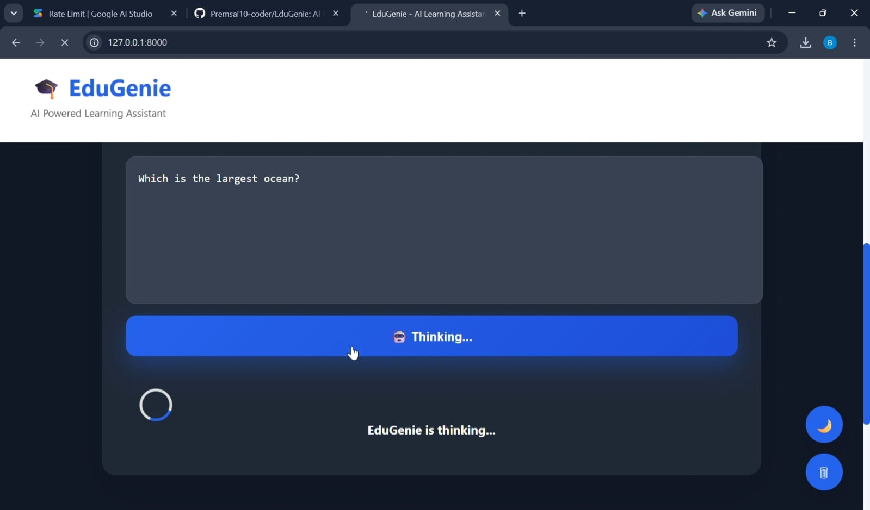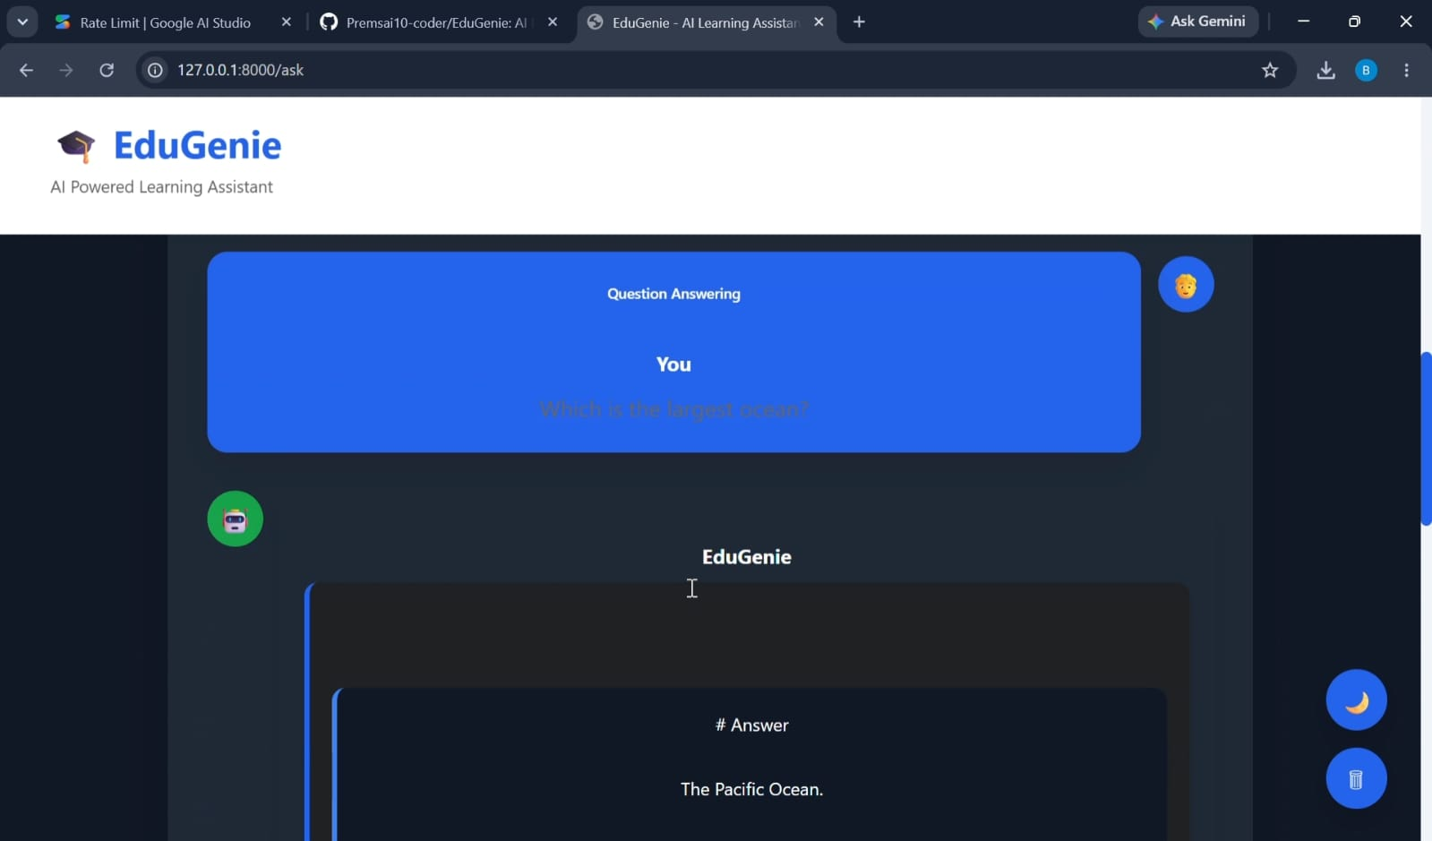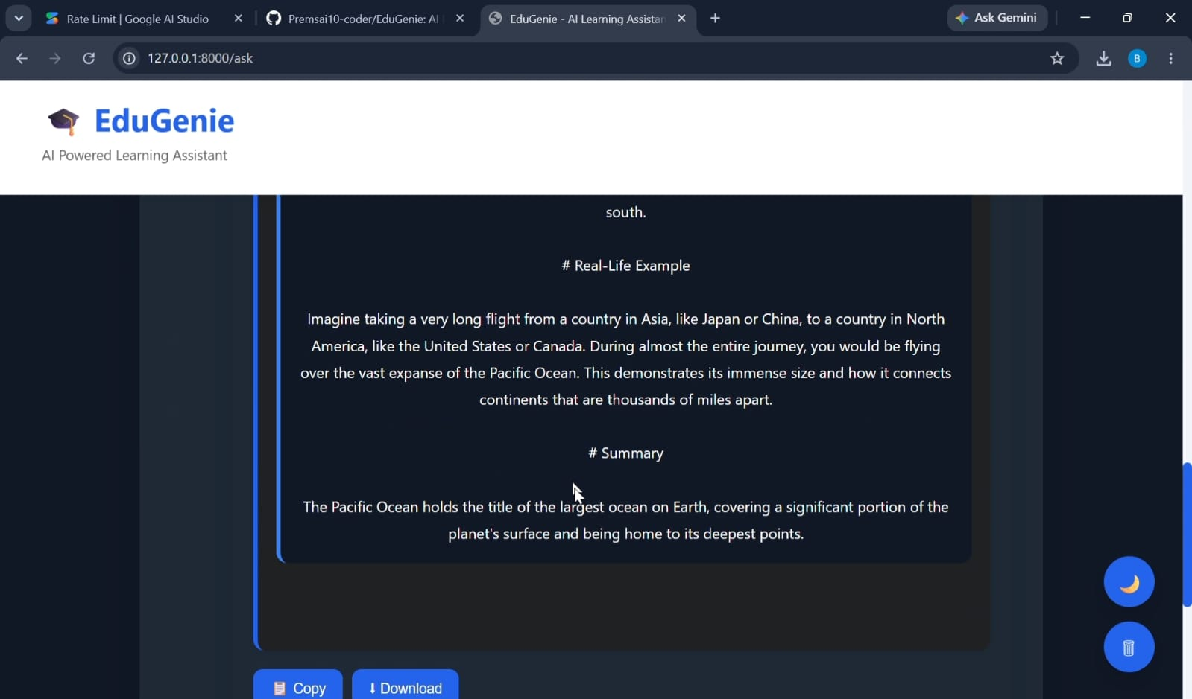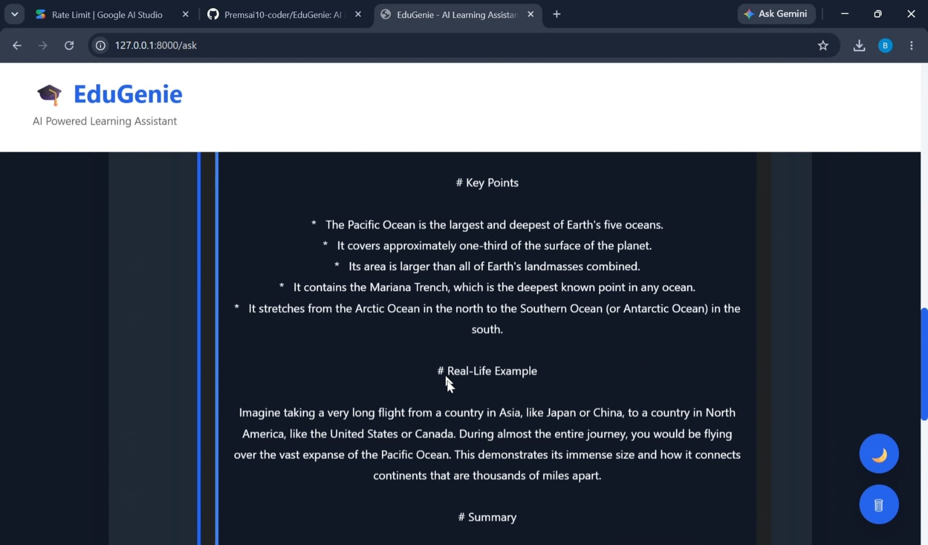
- Explanation Module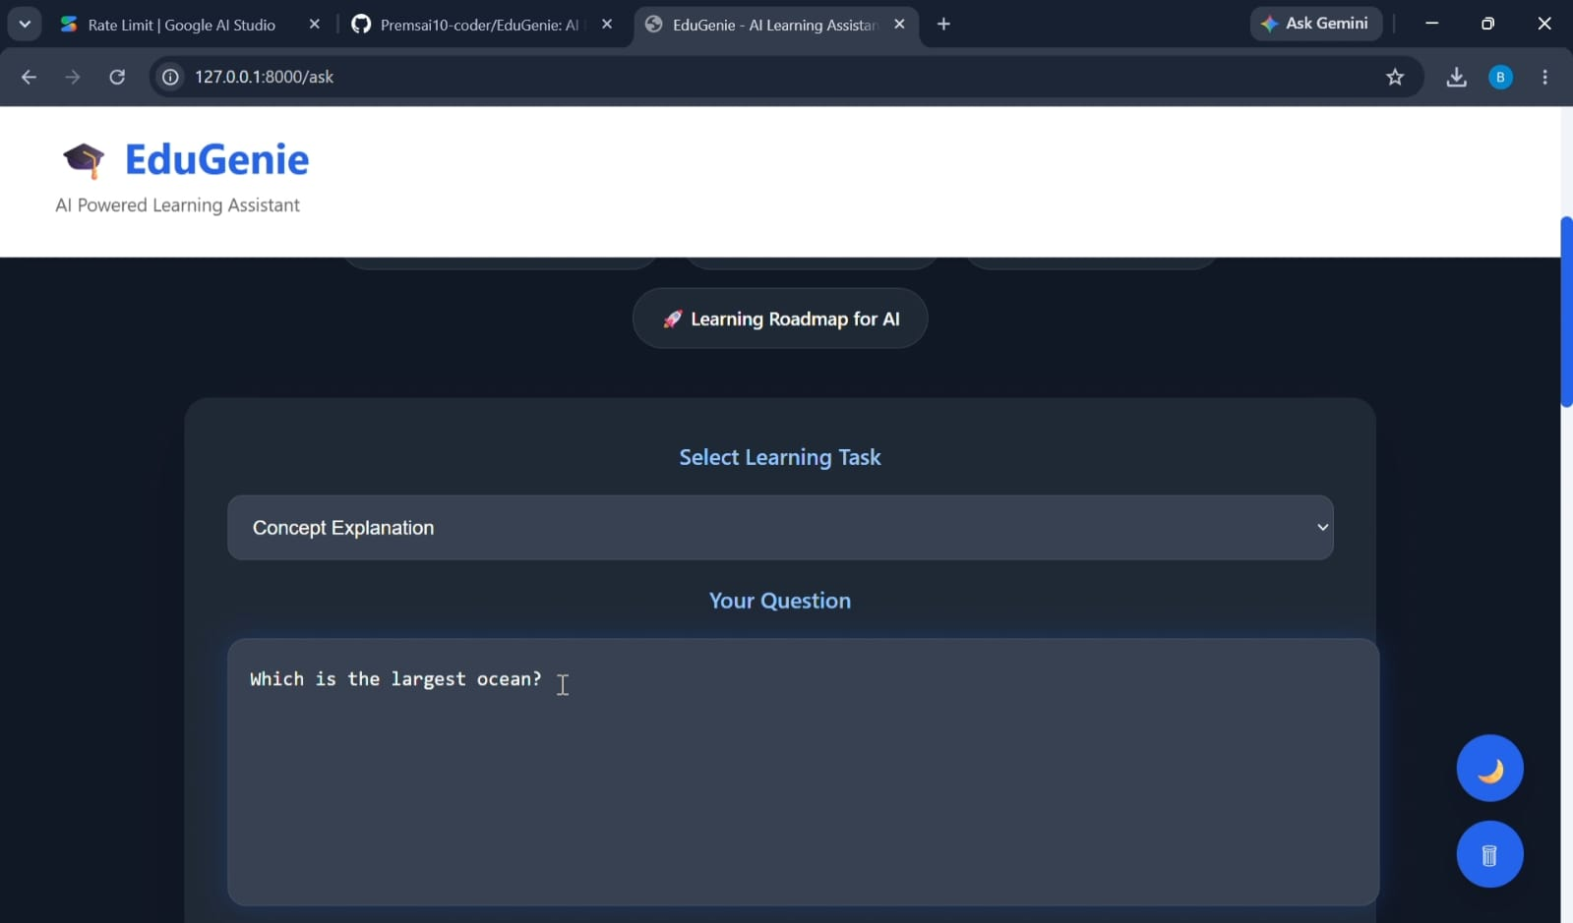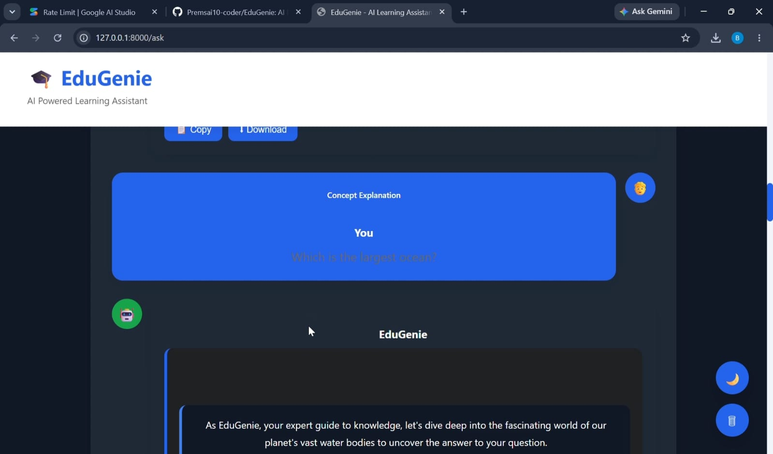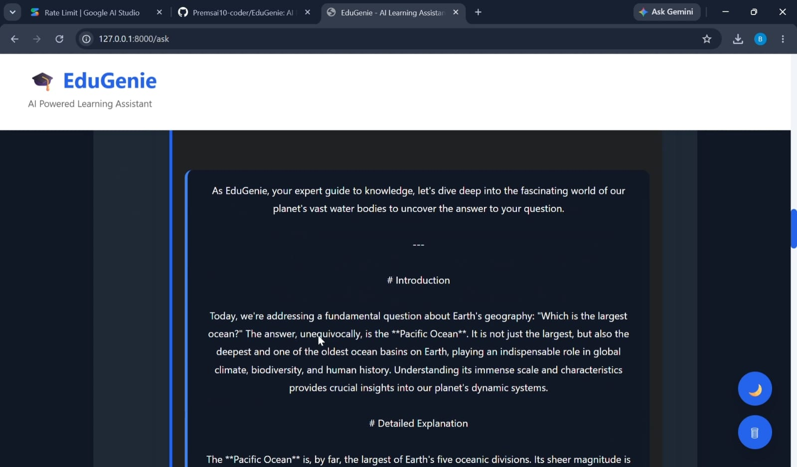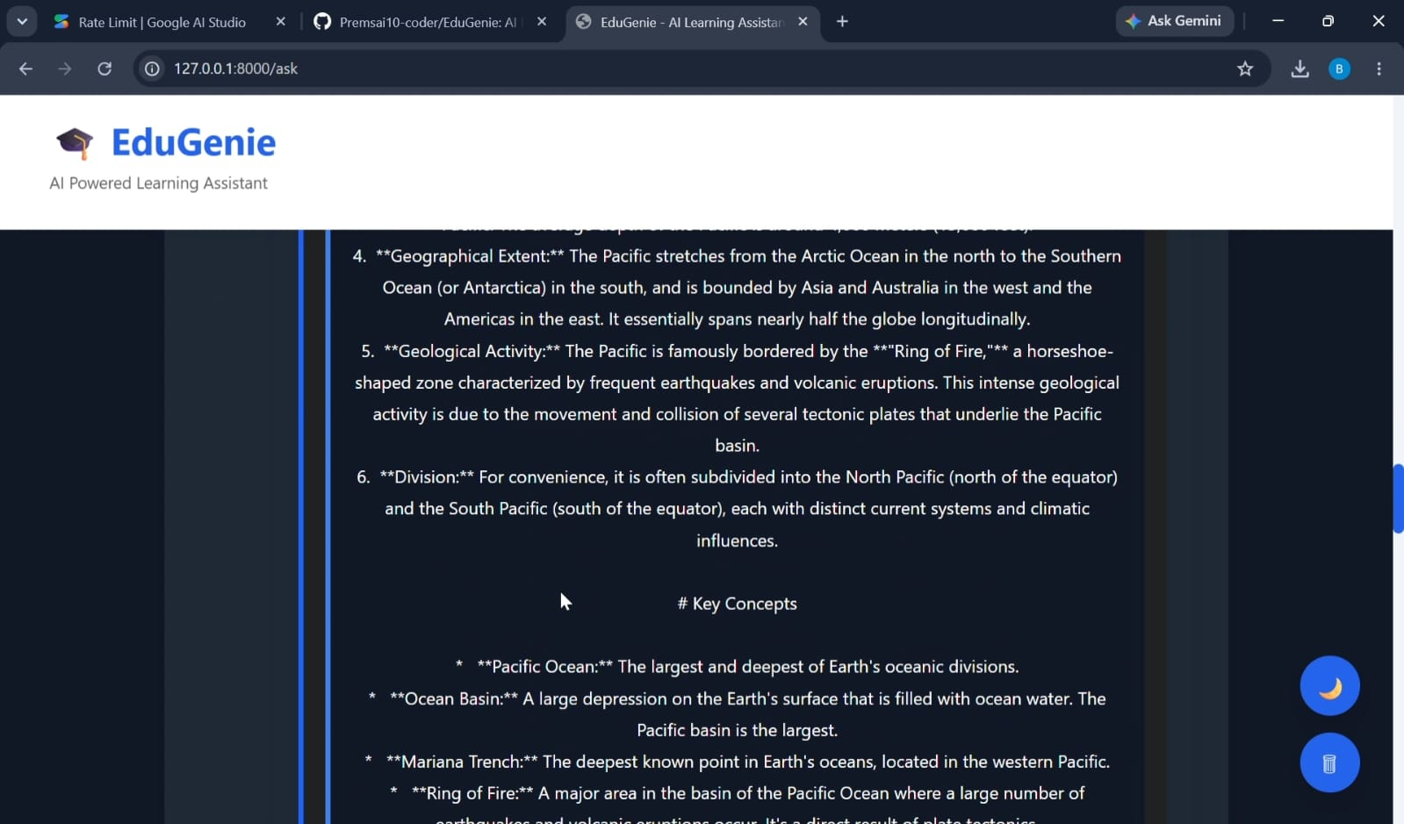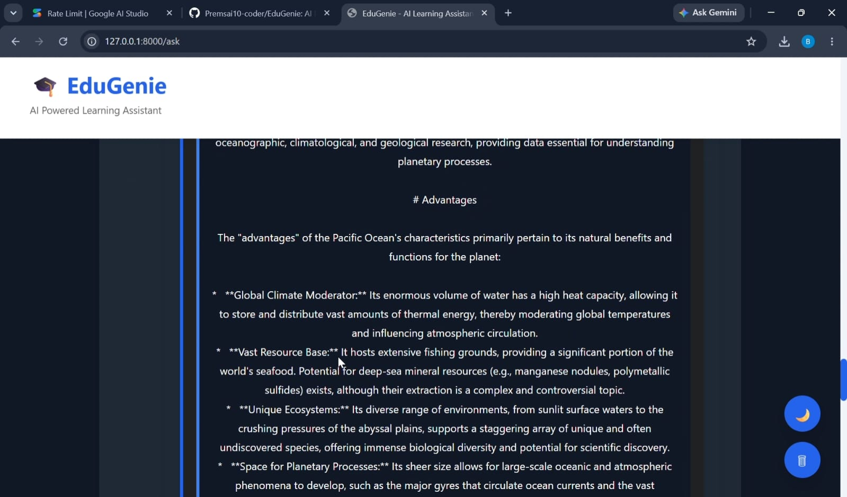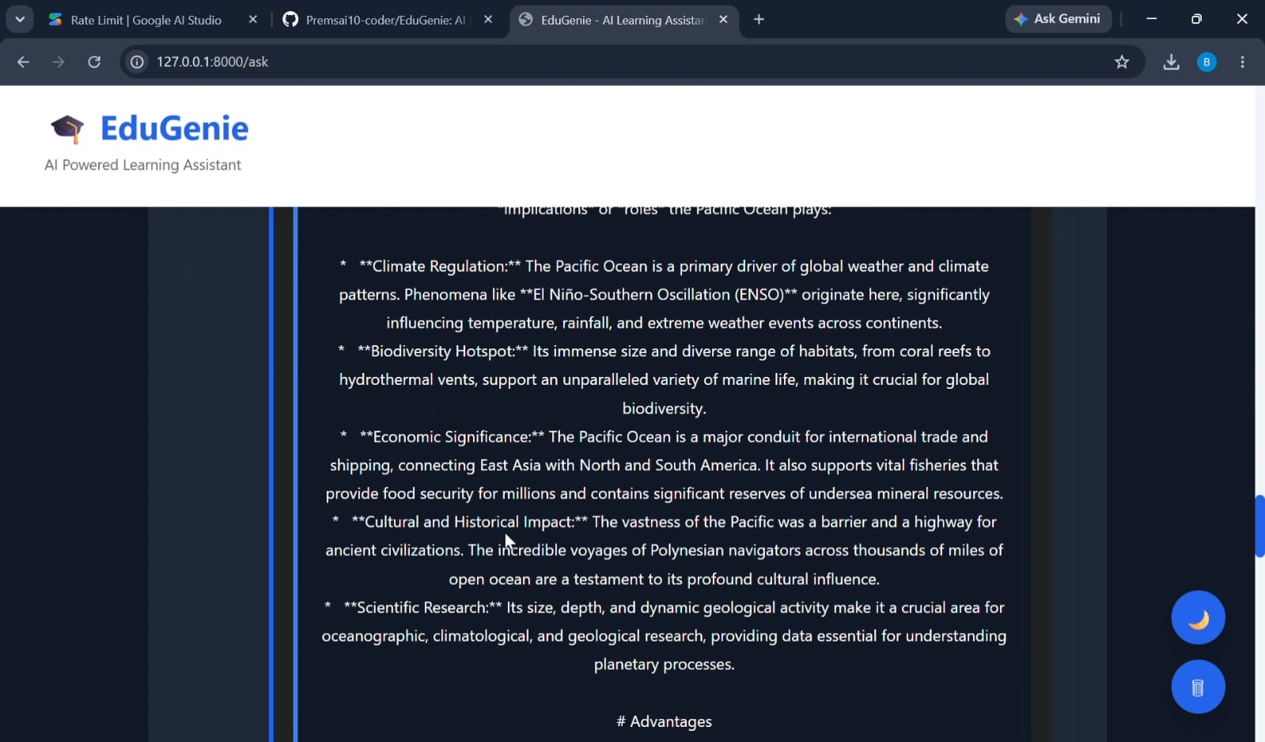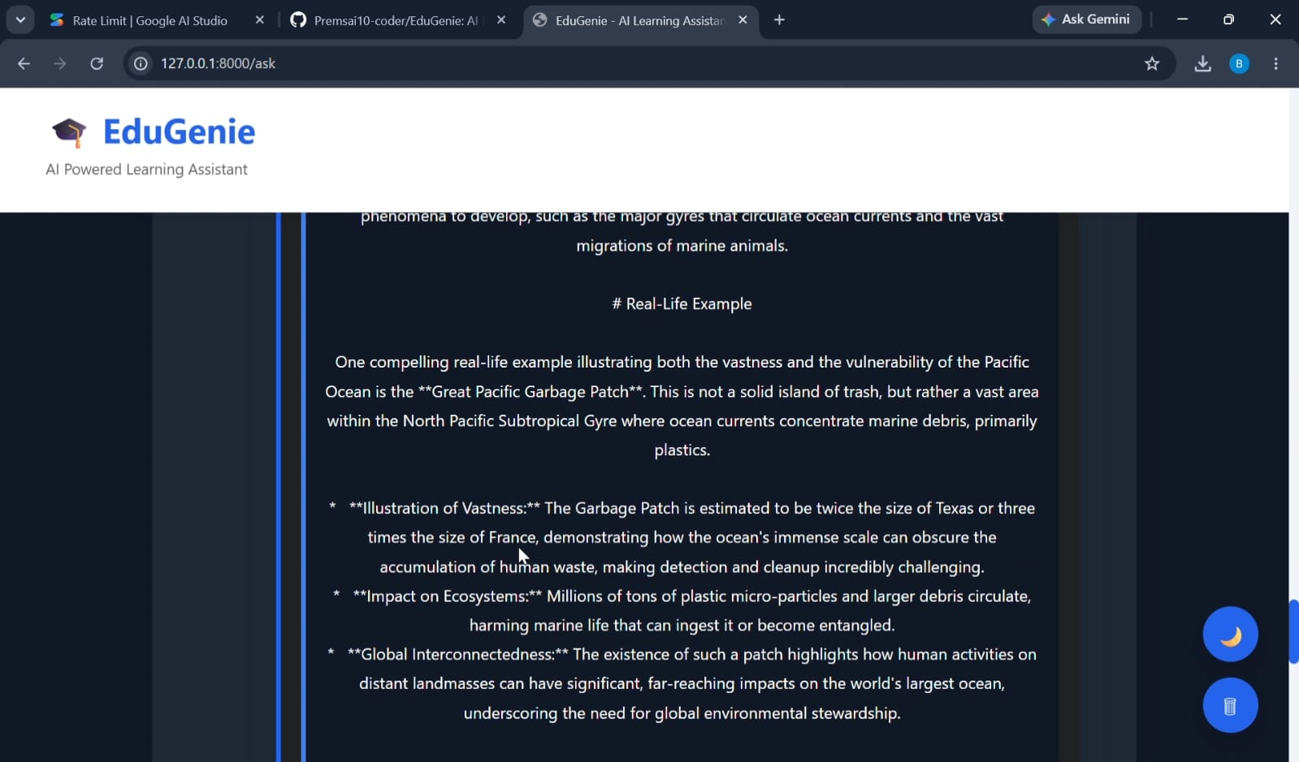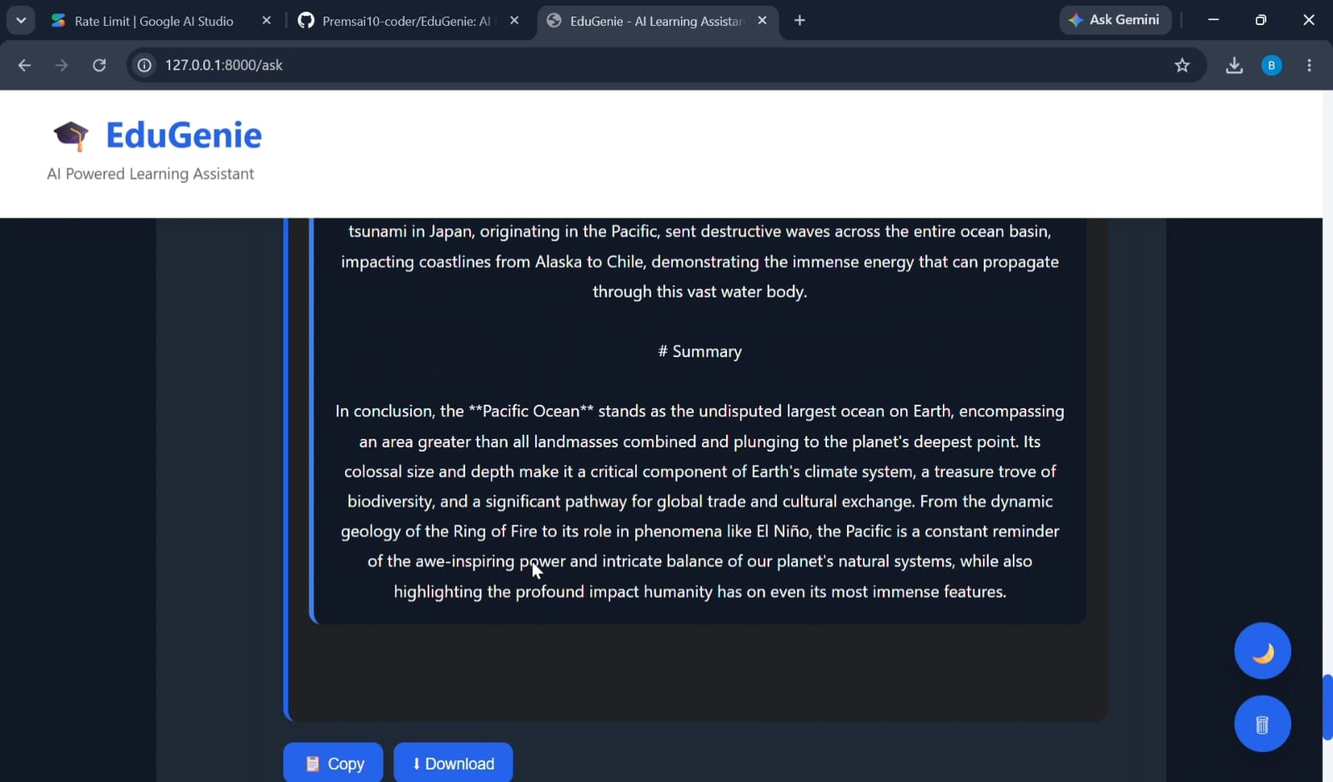
- Quiz Generation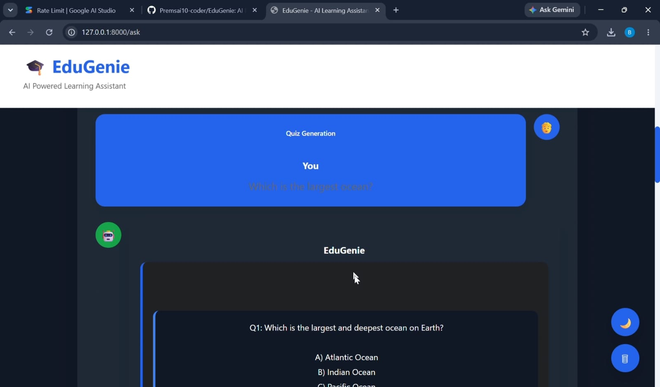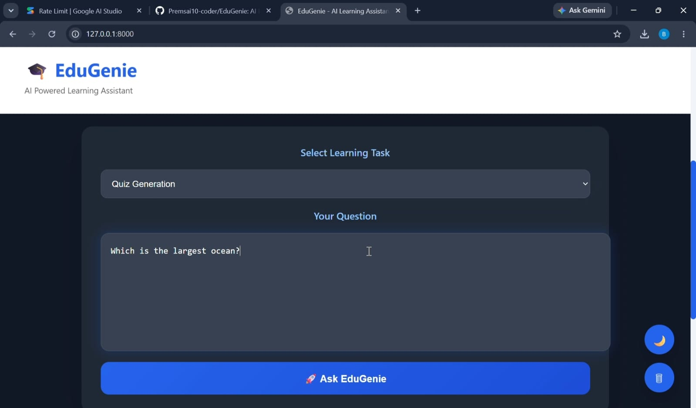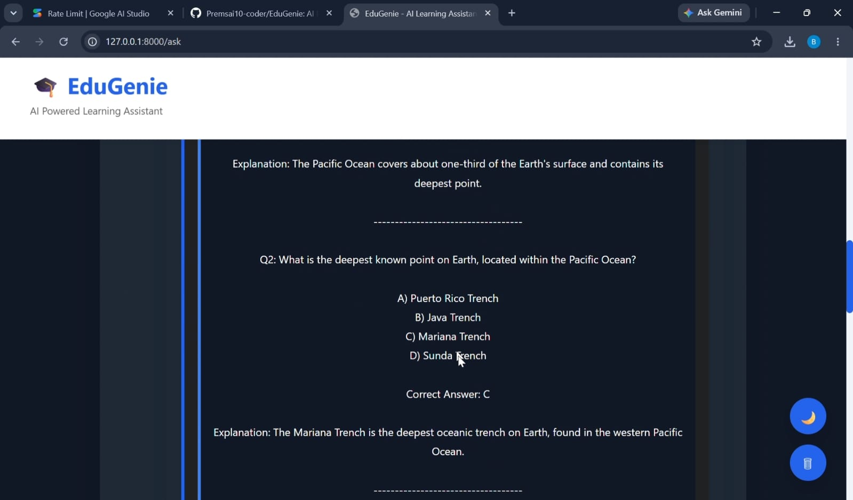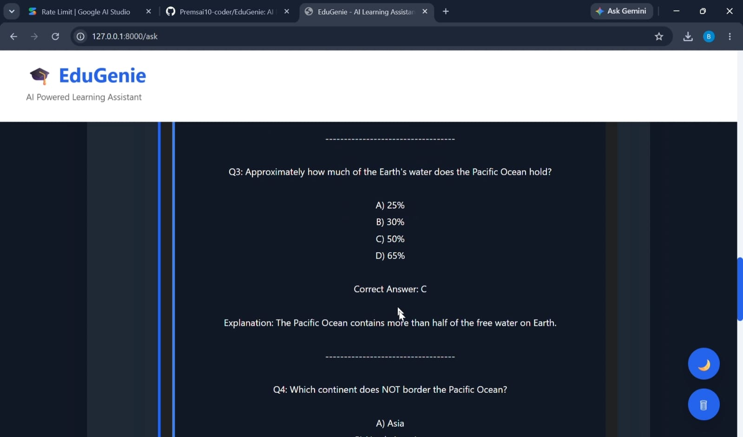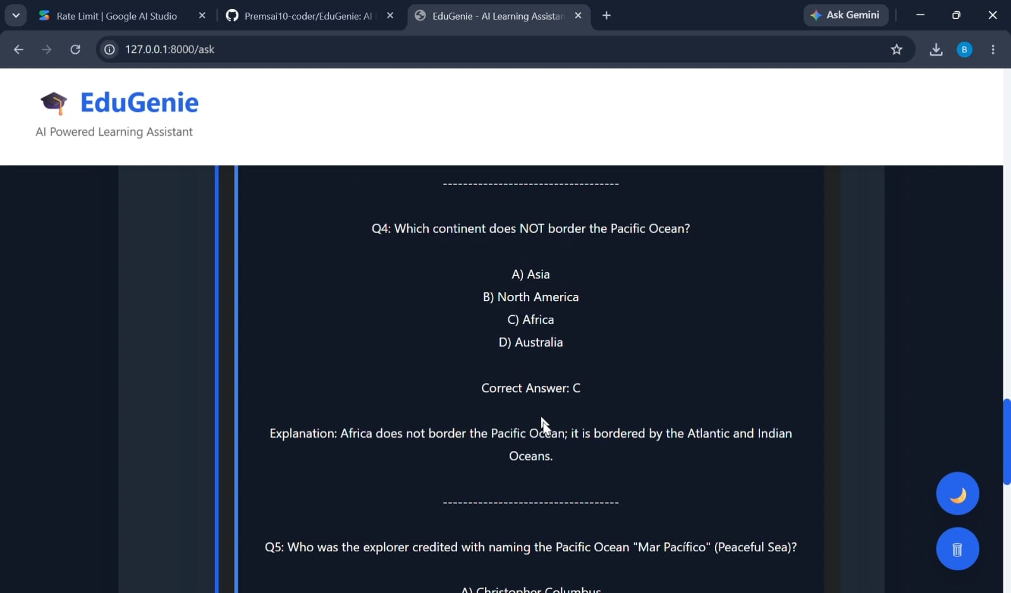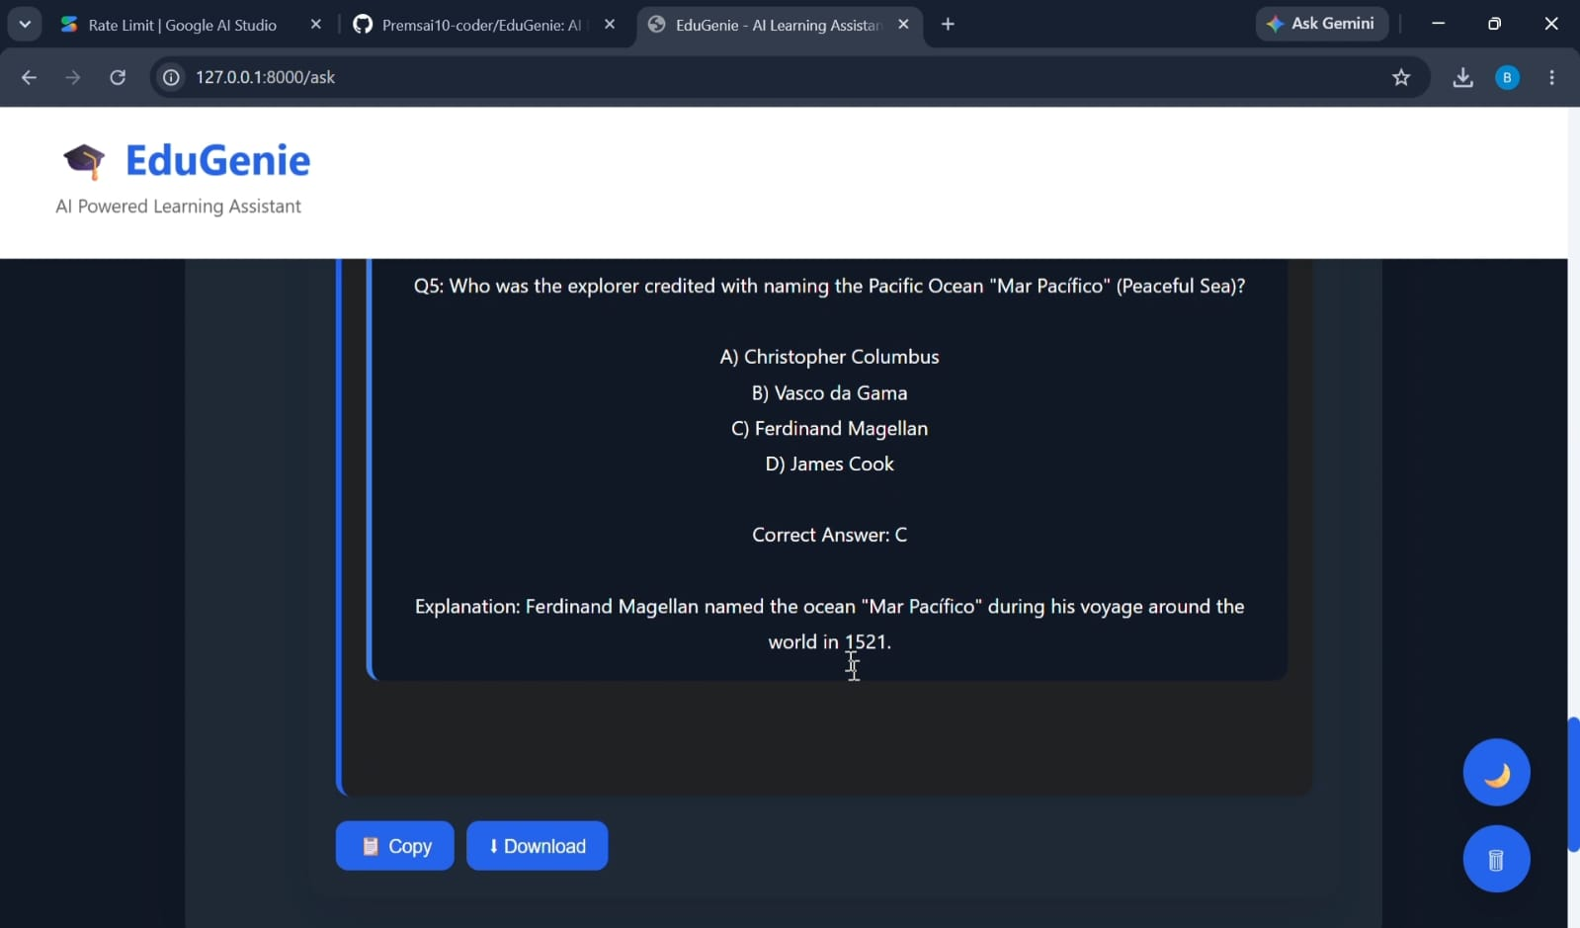
- Summary Generation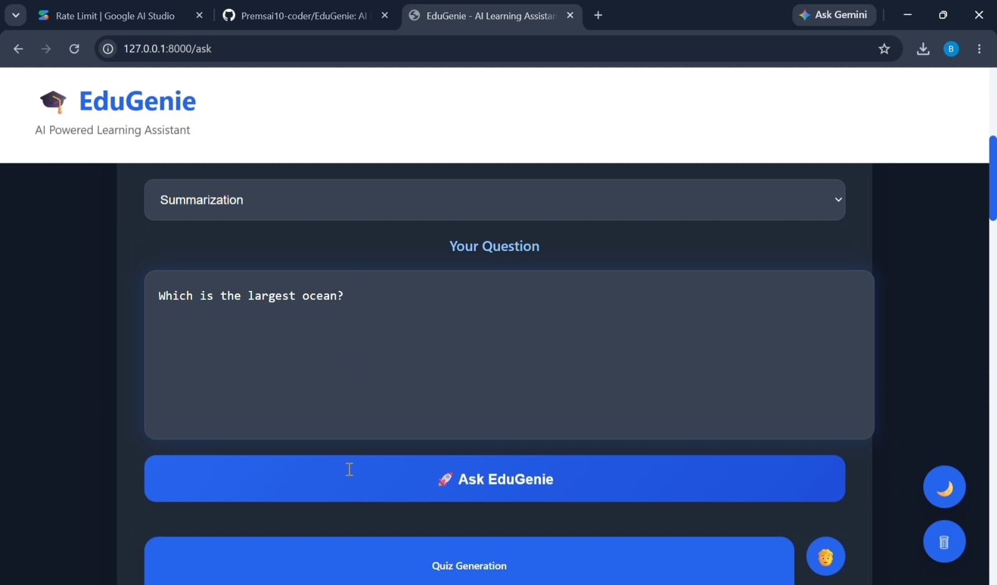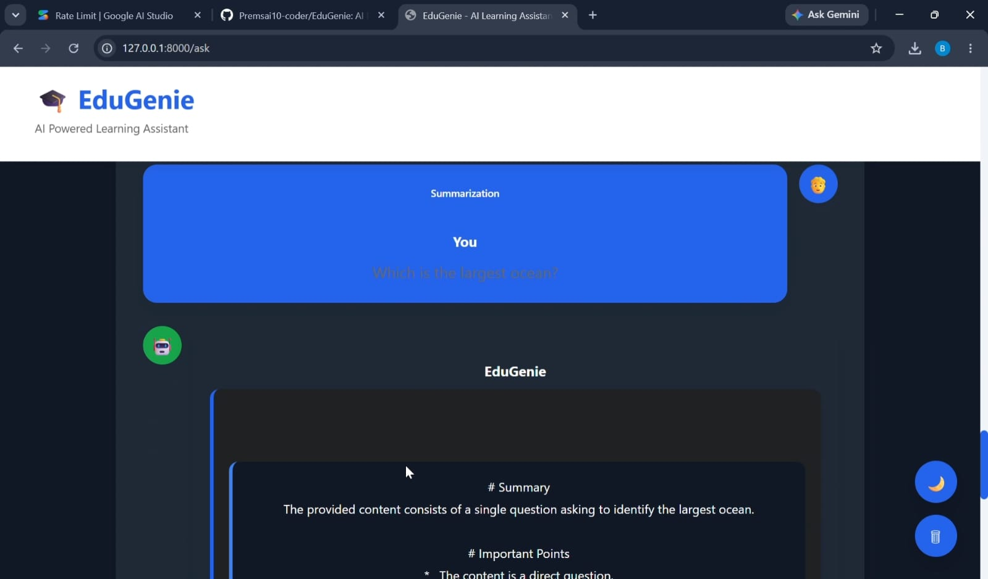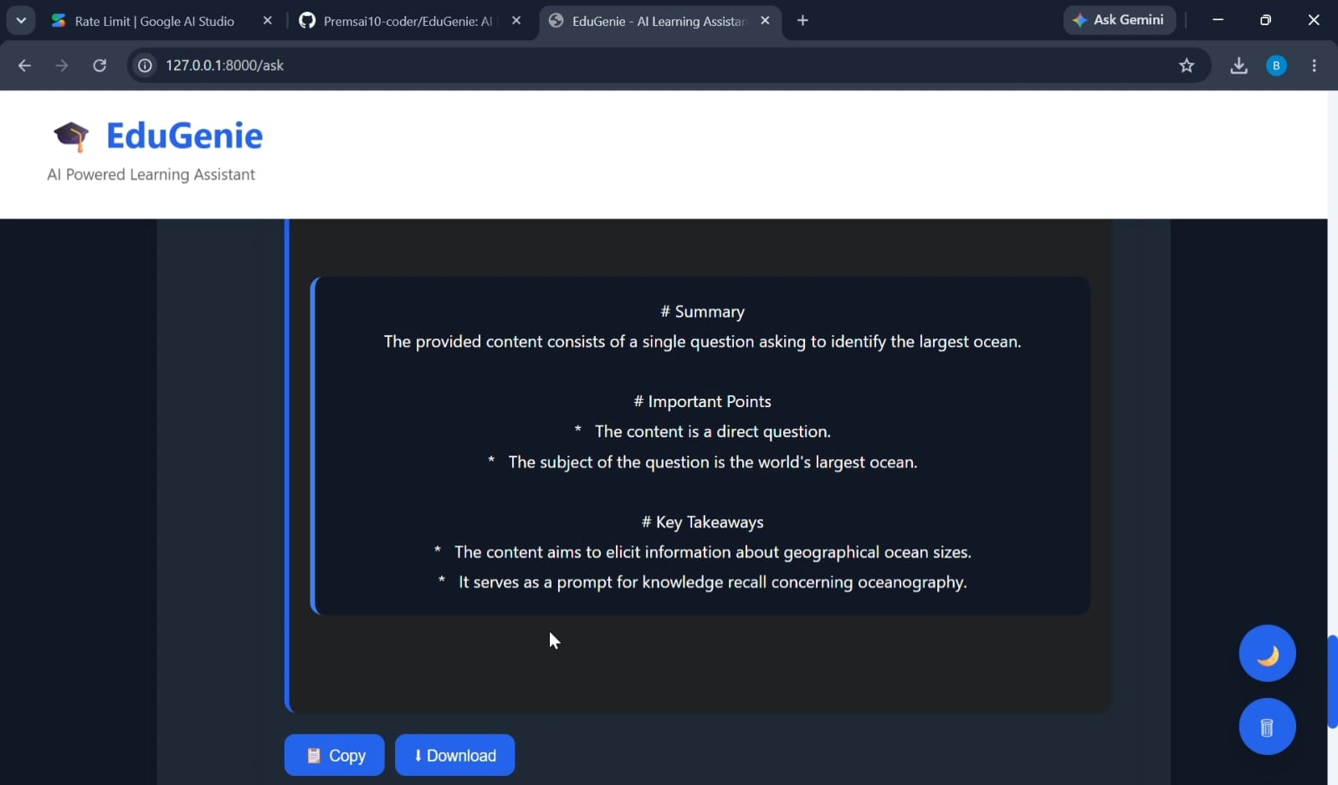
- Learning Recommendation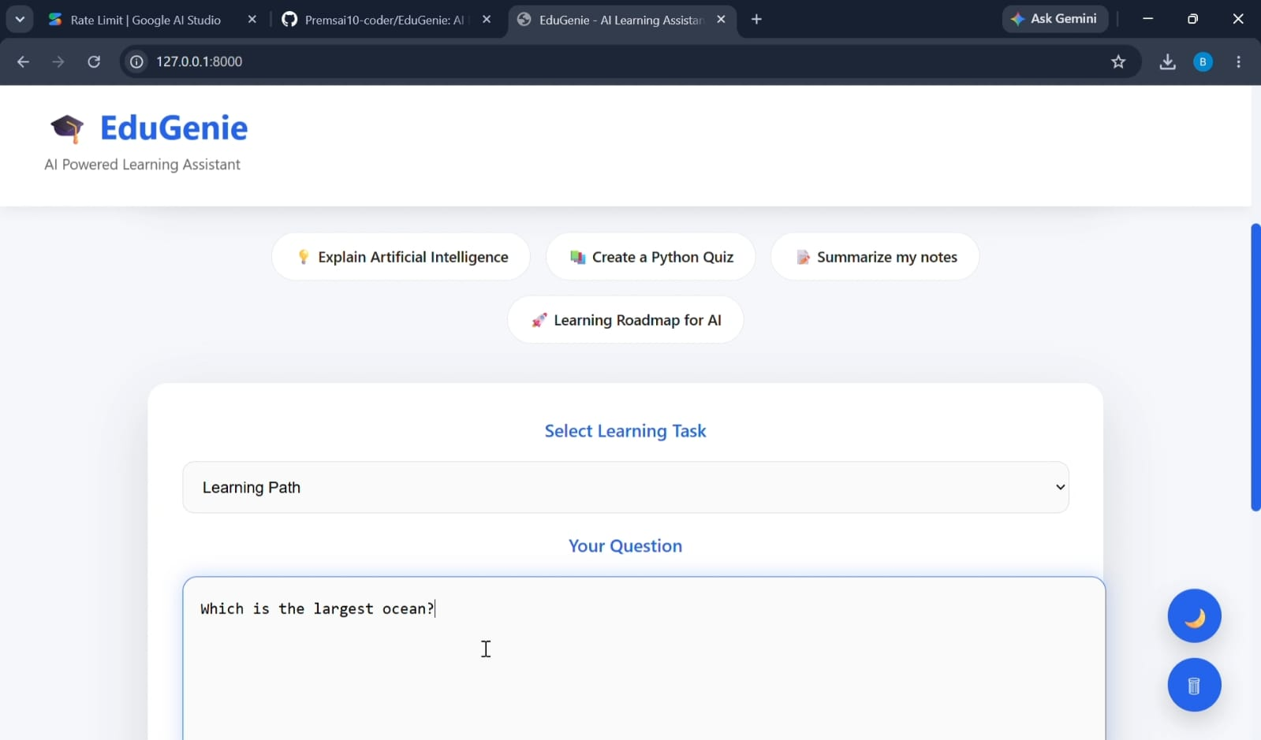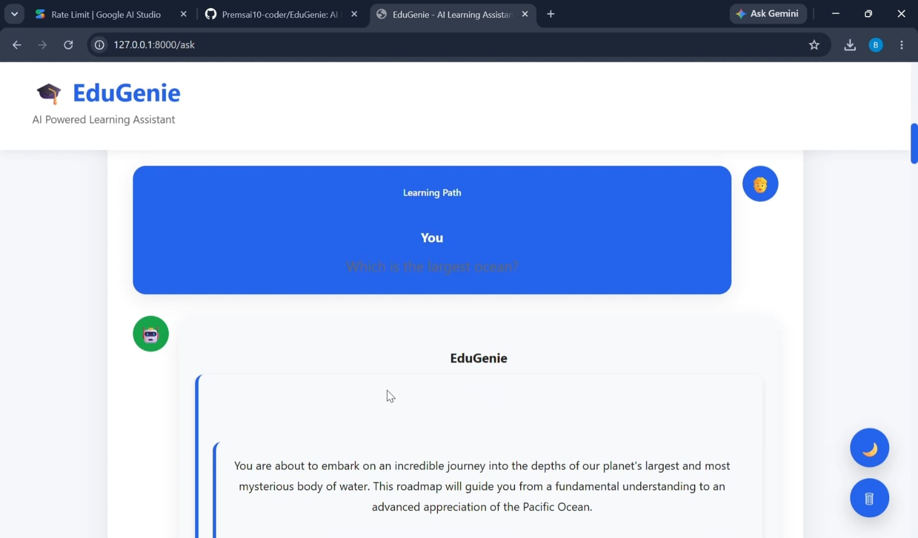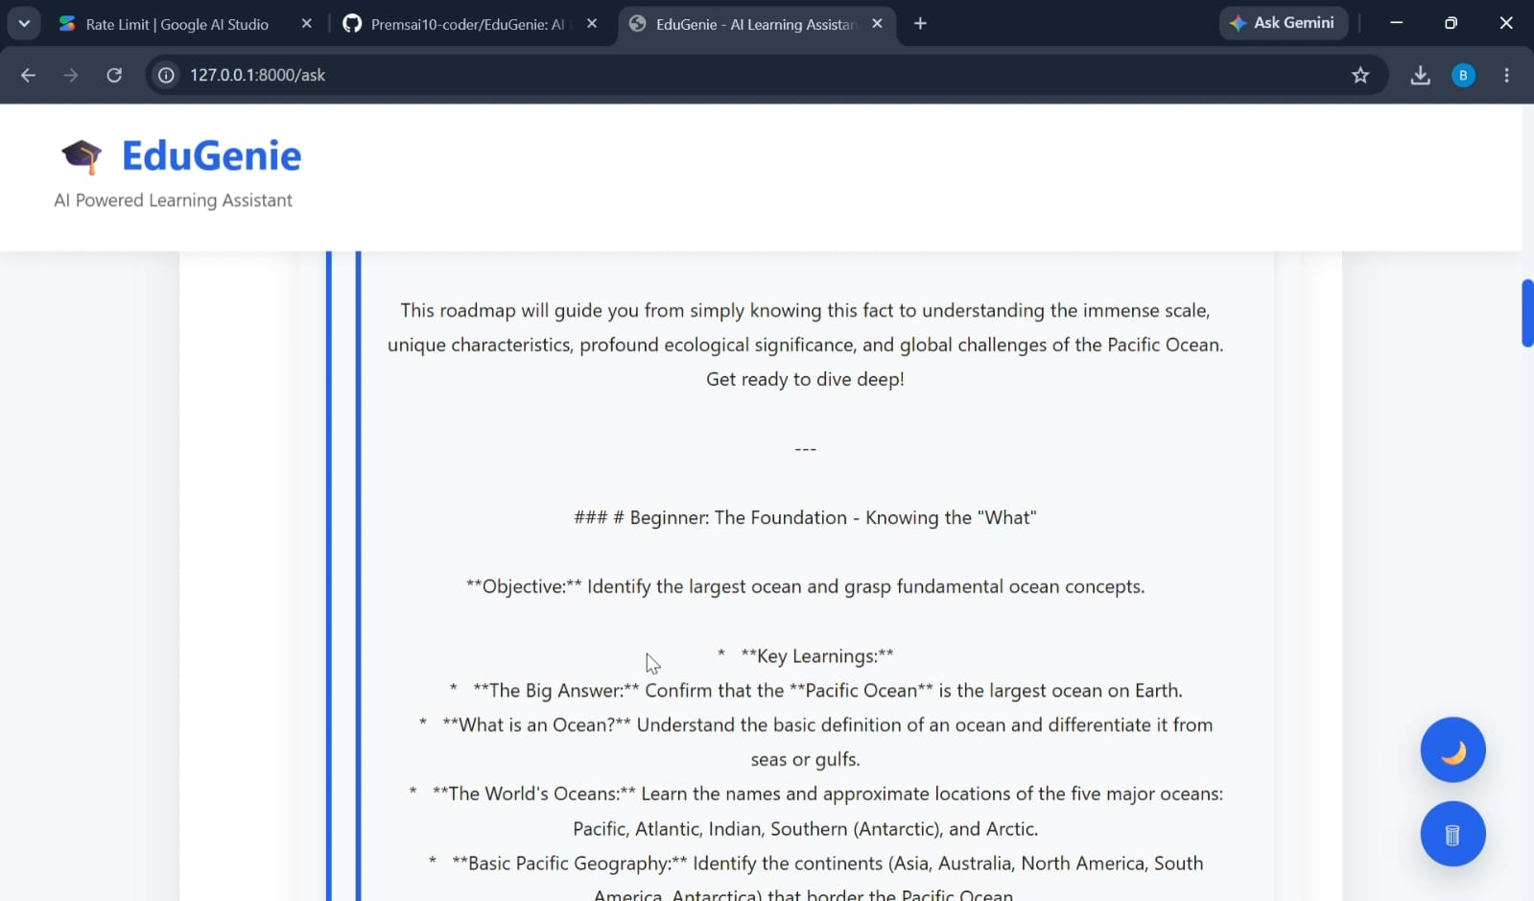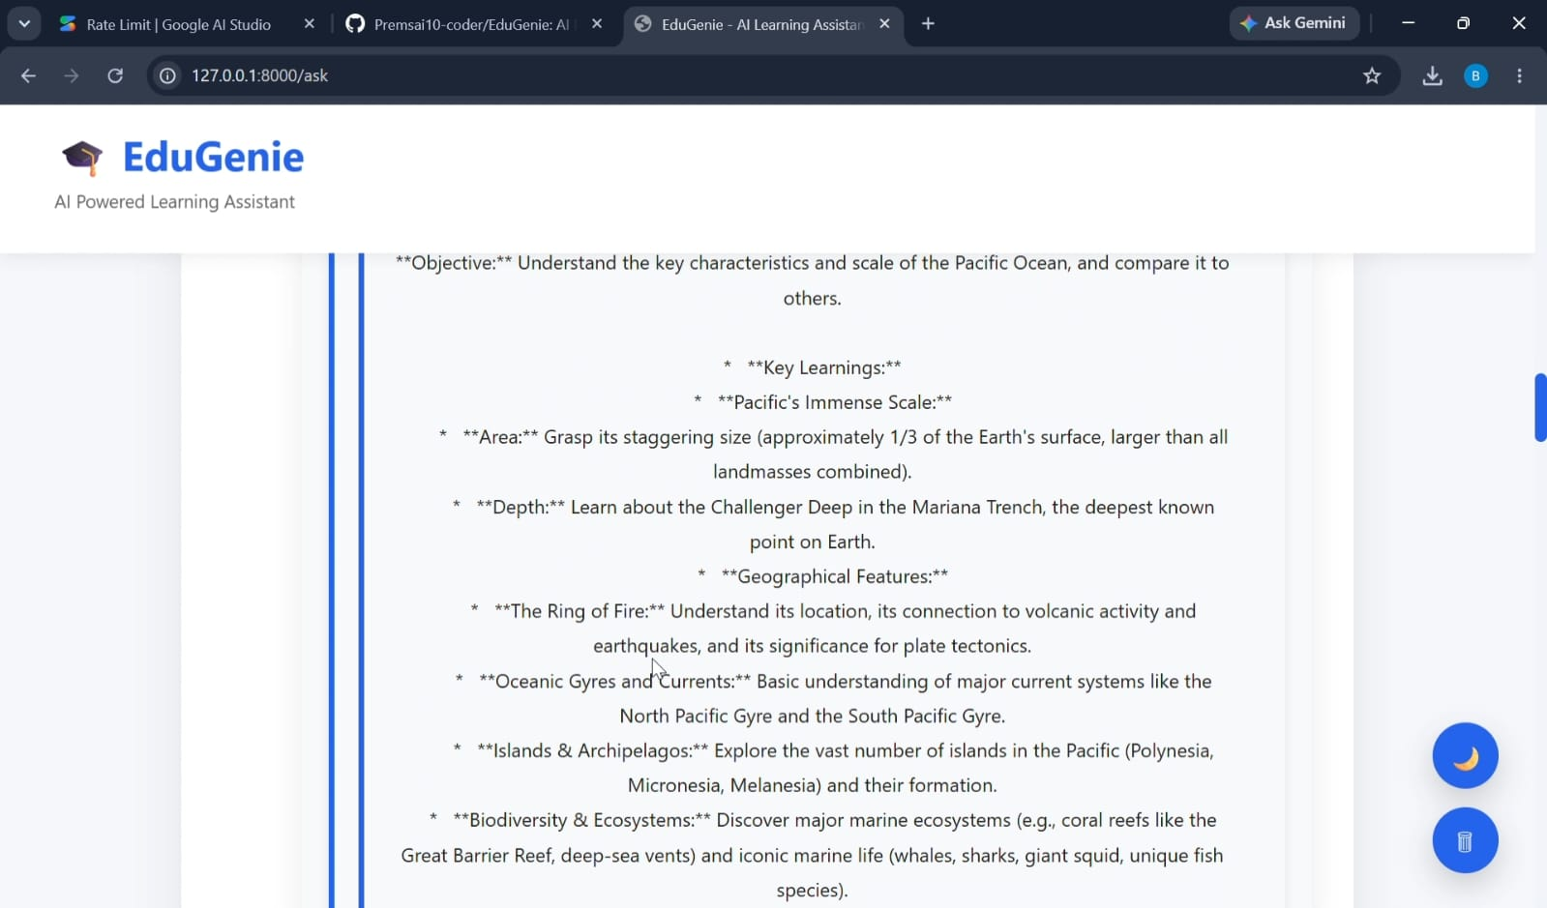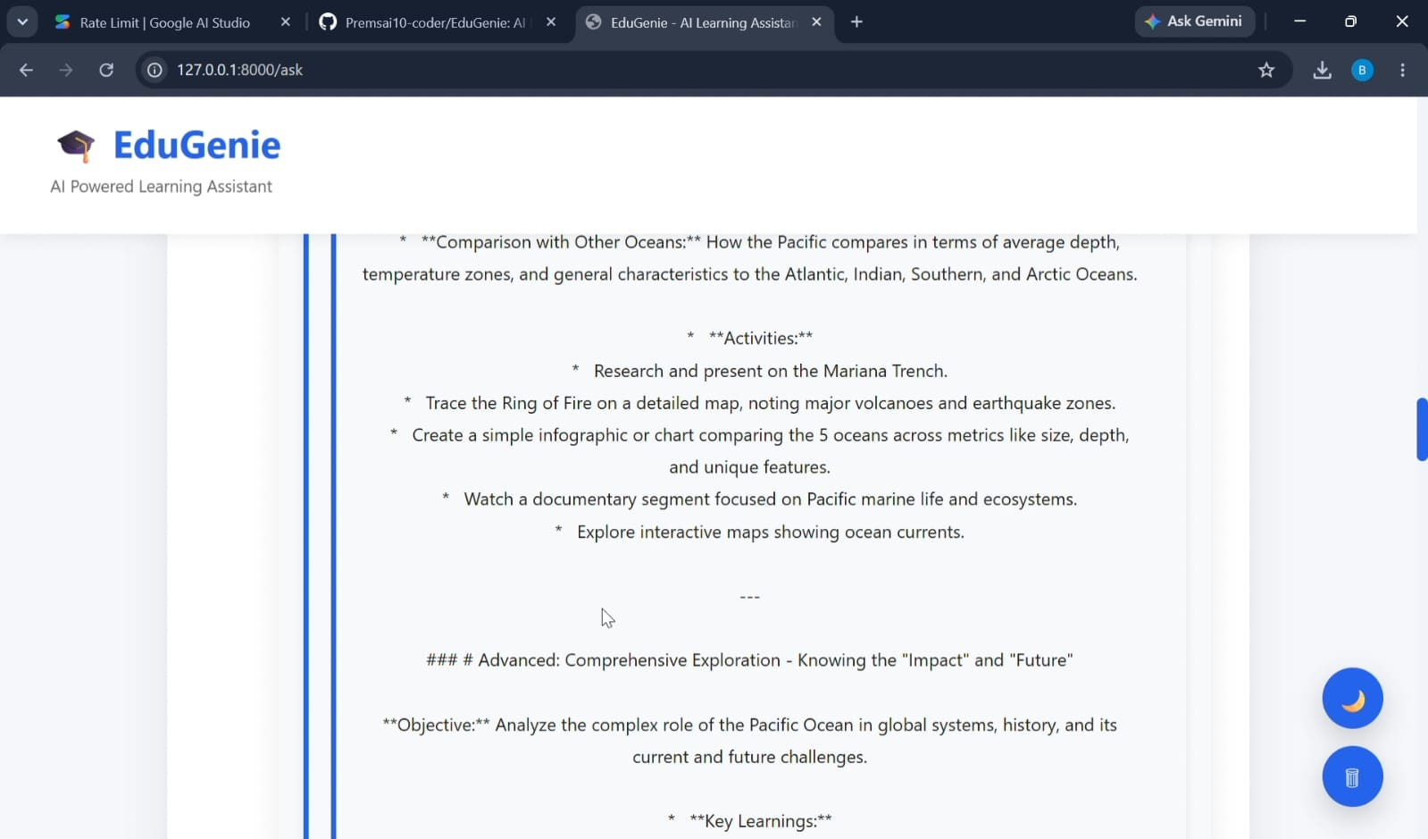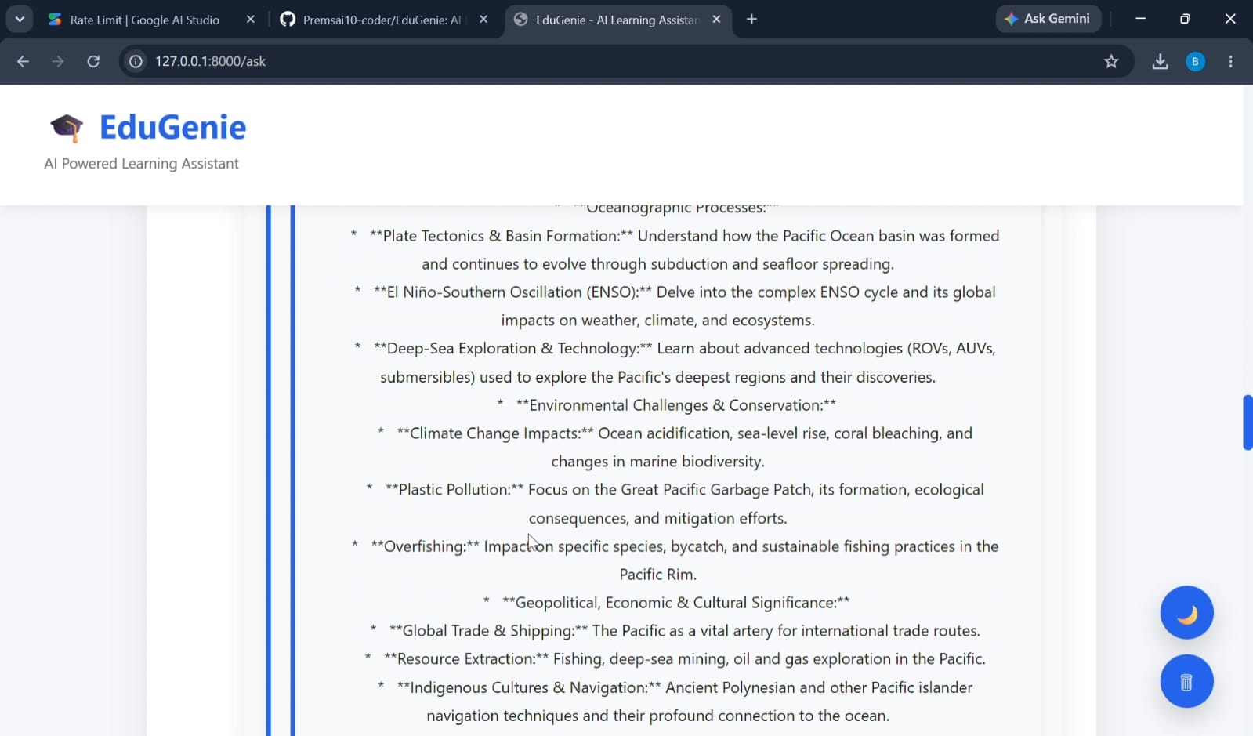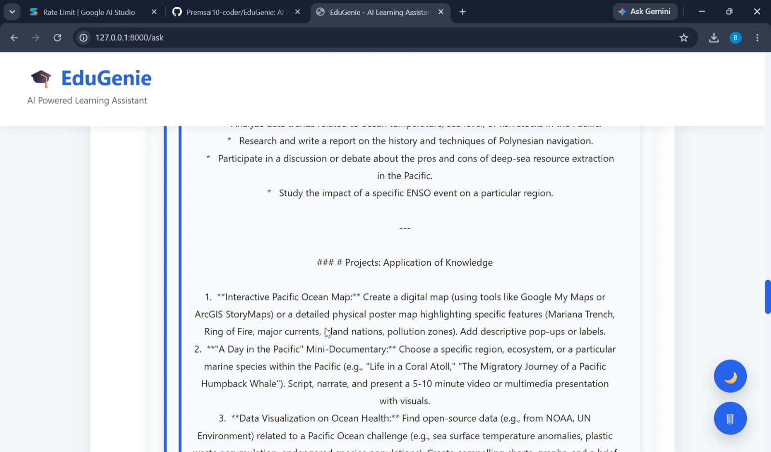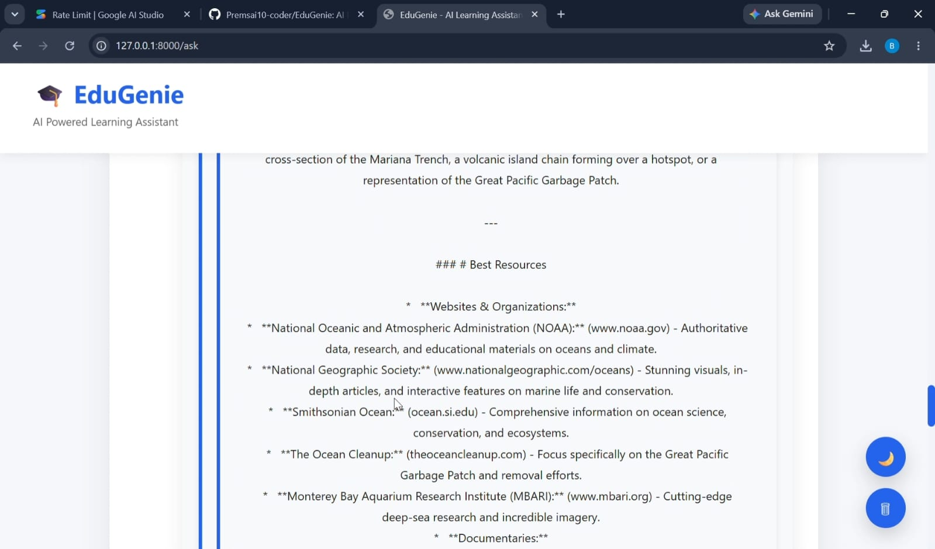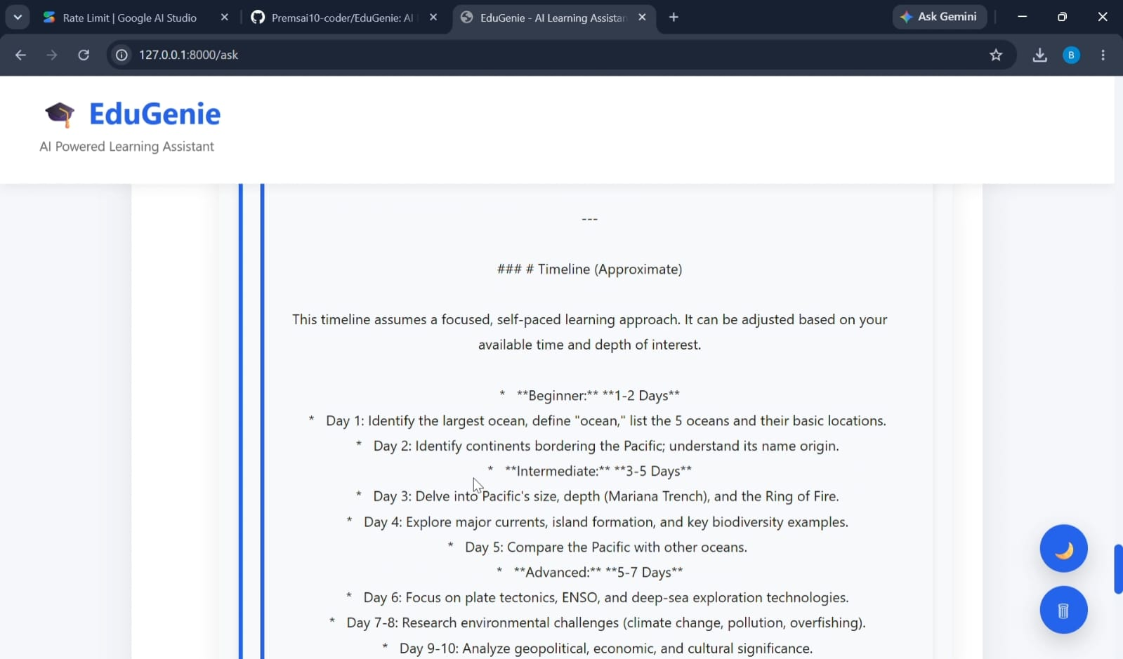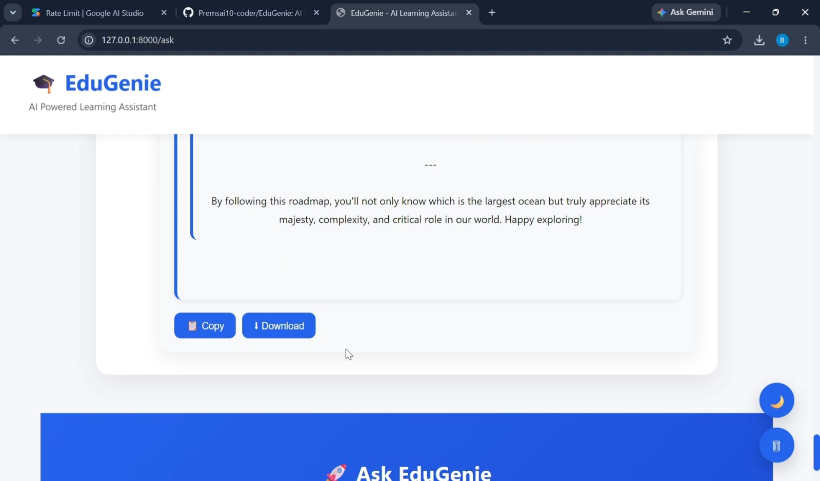
- FastAPI Terminal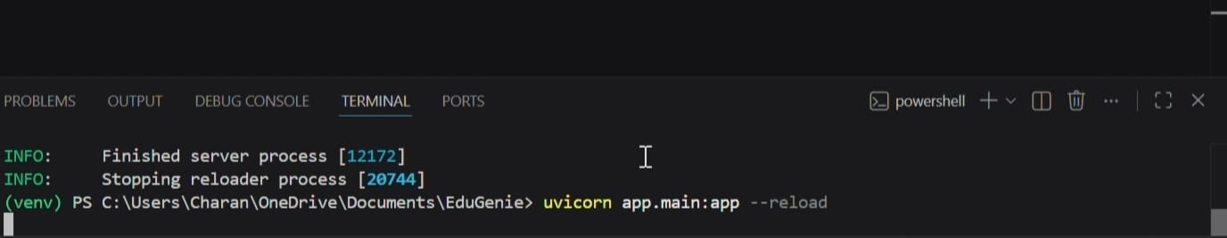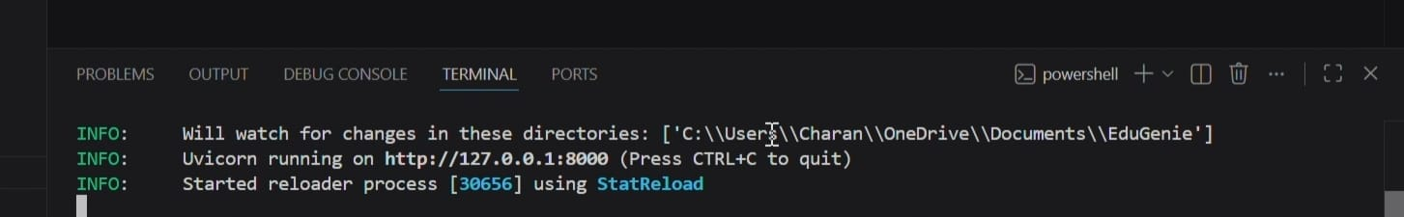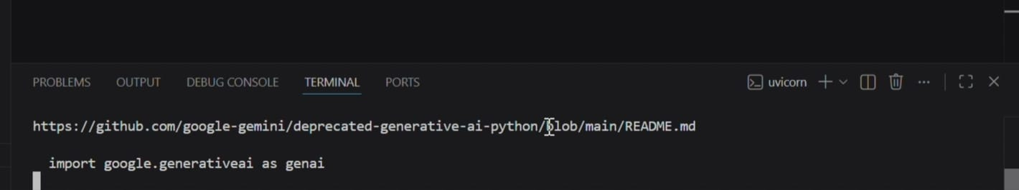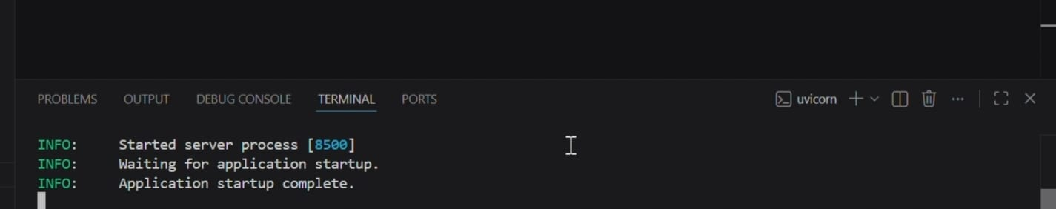
- Database Tables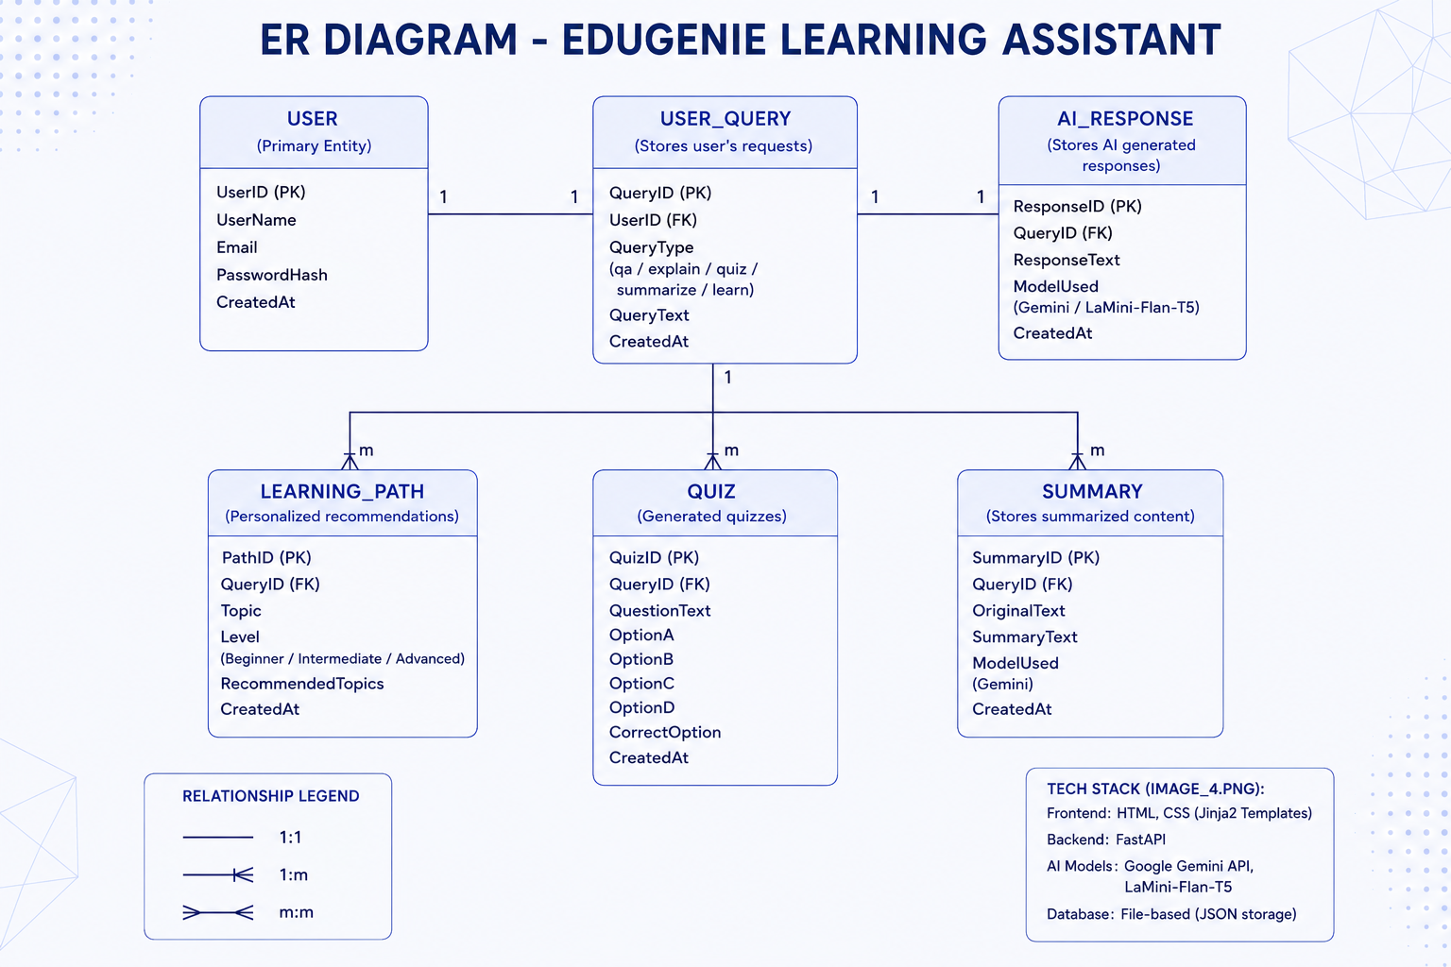
- API Output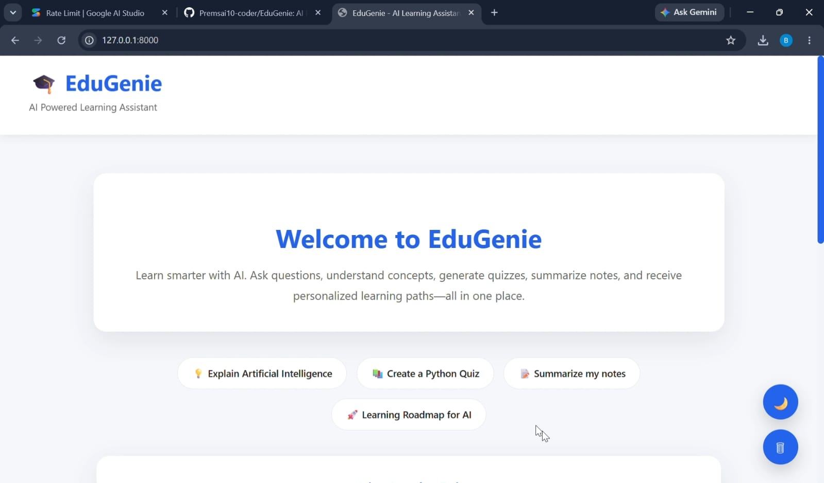


8. ADVANTAGES & DISADVANTAGES
Advantages
- Intelligent AI-powered learning
- Personalized recommendations
- Easy-to-use interface
- Fast responses
- Lightweight architecture
- Modular design
- Cloud-ready architecture
- Easy deployment
Disadvantages
- Internet required for Gemini API
- AI responses depend on API availability
- Limited offline functionality
- Requires API key configuration
- Advanced features depend on cloud services

9. CONCLUSION
EduGenie successfully demonstrates the application of Generative AI in education by integrating Google Gemini 1.5 Pro and LaMini-Flan-T5 into a unified learning platform. The system provides intelligent question answering, concept explanation, quiz generation, text summarization, and personalized learning recommendations through a responsive FastAPI-based web application.
The modular architecture ensures maintainability, scalability, and efficient frontend–backend communication. Functional and performance testing confirmed that all core features operate correctly, making EduGenie an effective educational assistant for students, educators, and self-learners.

10. FUTURE SCOPE
Future enhancements include:
- Voice-based interaction
- Multilingual support
- Mobile application
- Student progress tracking
- AI-powered analytics dashboard
- Learning Management System (LMS) integration
- Cloud deployment
- Adaptive learning
- Real-time collaboration
- Offline AI model support

11. APPENDIX
Source Code
EduGenie/
│
├── main.py
├── database.py
├── models.py
├── schemas.py
├── config.py
├── requirements.txt
├── .env
├── README.md
│
├── modules/
│ ├── __init__.py
│ ├── qna.py
│ ├── explanation_module.py
│ ├── quiz_module.py
│ ├── summary_module.py
│ └── learning_path.py
│
├── templates/
│ └── index.html
│
├── static/
│ ├── style.css
│ ├── script.js
│ └── logo.png
│
└── database/
└── edugenie.db
GitHub Repository
Add your GitHub repository link.
Project Demo
https://drive.google.com/file/d/1nGB2YybPeY-Nbu7Gz2B35cqYS5SYUUVm/view?usp=drivesdk
References
- Python Documentation
- FastAPI Documentation
- Google AI Studio (Gemini API)
- Hugging Face Transformers (LaMini-Flan-T5)
- HTML & CSS Documentation
- SQLAlchemy Documentation
- SQLite / PostgreSQL Documentation
This follows the structure in your uploaded template and is tailored to the EduGenie project. You can copy it directly into your report and add your screenshots, GitHub link, demo link, team details, and submission date where appropriate.

